Knowledge Exchange Ethics Self-Assessment form
This form is to be completed by lead applicants to determine whether an application for Leeds Trinity University ethical approval is required for the KE activity.
Office use only
Application number:

Date application received:

Outcome:

To be completed by the Lead applicant
Name:

LTU email address:

School/Institute:

Subject area:

Project title:

Please answer ALL of the questions below by inserting YES or NO in the final column of the table:
Will your KE activity …….?
1 | Involve testing a research question, hypothesis or completion of a clinical trial?
2 | Produce generalisable or transferable new findings?
3 | Require participants to be randomised to different groups?
4 | Require any treatments, interventions, processes or services to be allocated by randomisation?
5 | Require changing treatment, intervention, processes or services from accepted standards or existing practice for any of the participants/service users involved?
6 | Collect / contain sensitive personal data?
7 | Include a financial incentive to participate in the work?
8 | Involve your own students, colleagues, or employees of the University?
9 | Take place outside the UK?
10 | Involve participants who are particularly vulnerable or at risk?
11 | Involve any participants who are unable to give informed consent?
12 | Involve data collection taking place BEFORE informed consent is given?
13 | Involve any deception or covert data collection?
14 | Involve a risk to the person(s) carrying out the work if participants beyond that experienced in everyday life?
15 | Cause (or likely to cause) physical or psychological harm or negative consequences?
16 | Use intrusive or invasive procedures?
17 | Involve the possibility of incidental findings related to health status?
18 | Fit into any of the follow security-sensitive categories: concerns terrorist or extreme group; commissioned by the military; commissioned under an EU security call; involves the acquisition of security clearances?

Classification
The following guidance will help classify your KE activity.
Enter YES in the box which applies to your KE activity
If you answered NO to all the above questions, your KE activity is not research and does not require Leeds Trinity University Ethical approval
If you answered NO to questions from 1 to 5, but YES to any question from 6-18 your KE activity is not research but is high risk and will require Leeds Trinity University Knowledge Exchange Ethical approval
If you answer YES to any questions from 1-5 your KE activity is research and will require Leeds Trinity University Research Ethical approval
If you answered YES to any questions from 1-5 your KE activity is research and YES to any questions from 6-18 your KE is also high risk and will require Leeds Trinity University Research Ethical approval
When considering the type of approval required for knowledge exchange projects, the following flowchart may be of use (figure 1), relating to the use of the knowledge exchange self-assessment form and decision-making process.
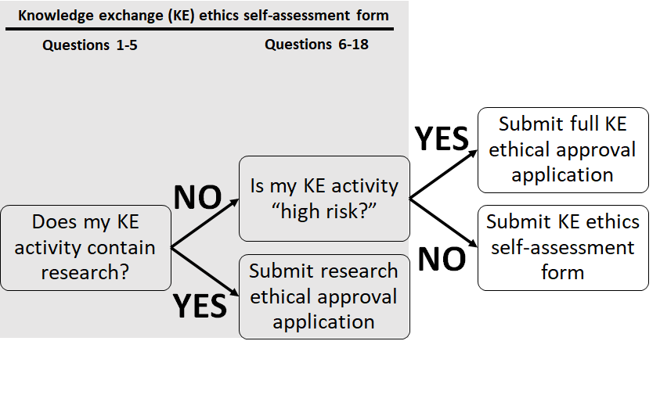
Figure 1: Flow chart outlining the decision-making process for knowledge exchange (KE) projects requiring ethical approval

NOTES
- If you are in any doubt or have questions regarding whether your KE activity is research and whether or not it requires Leeds Trinity University Ethics approval and/or
- If you are unsure if any external permissions or ethical review is required for the KE activity, and you are:
- A student: seek further advice from your supervisor or tutor;
- A member of academic staff: seek further advice from the chair of the University Research Ethics & Integrity Committee, the Chair of your School/Institute Research Ethics & Integrity Committee.

Please submit this completed form to ethicscommittee@leedstrinity.ac.uk

